**Test Case – B1 Amendment**

.

.

.

.

.

.

.

.

.

.

.

.

.

.

.

.

|  |  |
| --- | --- |
| **Version:** | 2.0 |
| **Author:** | Alexander Vejling Sennefelder |



**Document history**

|  |  |  |  |  |
| --- | --- | --- | --- | --- |
| **Version** | **Date** | **Author** | **Status** | **Comments** |
| 0.1 | 10-10-2022 | Alexander Vejling Sennefelder | Draft | Original Draft |
| 0.2 | 11-10-2022 | Alexander Vejling Sennefelder | Draft | Improved |
| 0.3 | 11-10-2022 | Tobias Heide Kaihøj | Review | Comments and grammatical |
| 1.0 |  | Alexander Vejling Sennefelder | Draft |  |
| 1.1 |  | Ida Mørck Jørgensen | Review |  |
| 2.0 | 22-10-2022 | Emma Hagerup | Preliminary approval | Document might be subject to change |

Table of contents

Contents

1 Pre-conditions 3

1.1 Process flow 3

2 Test Scenarios 4

2.1 Description of test scenarios 4

2.2 Test scenario 1 – Acceptance 5

2.2.1 XML example 6

2.3 Test scenario 2 – Rejection 6

2.3.1 XML example 6

# Pre-conditions

To complete the functional test case for “B1 Amendment”, the company must have an established connection to the AS4-gateway, and have a functioning system user to DMS Export, see [Connectivity Guide&System Guide](https://github.com/skat/dms-public-private/tree/master/Onboarding%20Documents).

Furthermore, ensure that you for this test case have the correct URLs, Services, and Actions, as seen below. In place of {CVR} and {UID}, fill out your own CVR and UID in the URLs below. While the URLs and Services are the same for all the test cases, the Actions however, will change depending on the test case you are performing, please keep an eye out that you have the correct Action for the test case in hand.

To submit the XMLs for this test case, use the following endpoints:

|  |  |  |  |
| --- | --- | --- | --- |
| **URL** | **UFE Service** | **TFE Service** | **Action** |
| **<https://secureftpgatewaytest.skat.dk:6384/exchange/CVR_{CVR}_UID_{UID}>** | DMS.Export2 | DMS.Export | Declaration.Submit |
| [**https://secureftpgatewaytest.skat.dk:6384/exchange/CVR_{CVR}_UID_{UID}**](https://secureftpgatewaytest.skat.dk:6384/exchange/CVR_%7BCVR%7D_UID_%7BUID%7D) | DMS.Export2 | DMS.Export | Declaration.Amend |

For retrieving the notification, use the following endpoint:

|  |  |  |  |
| --- | --- | --- | --- |
| **URL** | **UFE Service** | **TFE Service** | **Action** |
| [**https://secureftpgatewaytest.skat.dk:6384/exchange/CVR_{CVR}_UID_{UID}**](https://secureftpgatewaytest.skat.dk:6384/exchange/CVR_%7BCVR%7D_UID_%7BUID%7D) | DMS.Export2 | DMS.Export | Notification |

Please ensure that the “**Test Case – B1 Standard**” have been completed **before** you try to complete the **“Test Case – B1 Amendment”** scenarios.

## Process flow

The process flow for a B1 standard declaration with an amendment request can be seen in the Figure below:

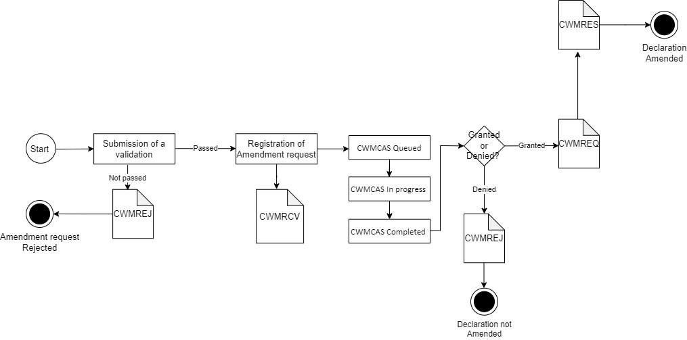

# Test Scenarios

To complete this test case, test scenario 1 and 2 must be passed successfully. Descriptions and specifics for each test can be found in the coming sections. Be sure to go through the scenarios thoroughly. It is recommended that you use the attached files to test the notifications.

|  |  |  |
| --- | --- | --- |
| **Test no.** | **Test scenario** | **Passed/Failed** |
| **1** | Submit B1 – Amendment XML, which is accepted | ☐ |
| **2** | Submit B1 – Amendment XML, which is rejected | ☐ |

## Description of test scenarios

The following sections will describe the aim of each specific scenario and provide the desired results of the test scenarios. It is worth noting that there can be changes in the notifications provided by DMS Export as the solution is still in development.

The purpose of the test scenarios is to ensure your connection to the system, and that you as a company can receive the correct notifications when sending in XMLs. Each step describes what you need to do when going through the test case. For each case there will be an XML available in the same folder where you found this test case document.

For both the Correction and Amendment test scenarios, it is important to note that System Specific Fields and Group 11 fields cannot be changed as part of the Correction or Amendment. The fields can be found in the [Export XML Guide.](https://github.com/skat/dms-public-private/tree/master/Onboarding%20Documents) For simplicity, the acceptance of the Amendment scenario will include changes to a field that is allowed to be amended. For the rejection scenario, the **Security** (11 07 001 000) field will be used.

The difference between Correction and Amendment is that an Amendment is submitted after acceptance of a declaration (after receiving the CWMACC notification) and generates a manual case task, after initial validation, to be handled by a customs officer and thereby accepted (or rejected).

## Test scenario 1 – Acceptance

The aim of this scenario is to get a notification that the B1 Amendment XML has been accepted.

The following table shows the necessary test steps for completing this scenario as well as expected results. For the first step it is recommended using the provided declaration XMLfound in the **Test Case** folder. Secondly, make sure that your **LRN** is unique, and that the **Submitter** field is correct (this is done by putting your CVR in the **Submitter/Name** and **Submitter/ID** fields) in the B1 Standard XML. Then go to the “**Statistical value**” (**99 06 000 000**) element in theXMLand ensure that it is as described in step no. 6.

|  |  |  |  |
| --- | --- | --- | --- |
| **Step no.** | **Description of steps** | **Expected result** | **Passed** |
| **1** | Submit a **B1 Standard Acceptance XML** (you can use the B1 Standard Acceptance XML from the B1 Standard test case). It is found in folder where you found this test case document folder (remember to replace the **{{LRN}}** and **{{CVR}}** placeholders) | You should have a template **XML** ready for the next step | ☐ |
| **2** | Submit the declaration using the conditions found under Pre-conditions | The declaration should be sent to the system | ☐ |
| **3** | Pull the notifications | You should be able to pull the notification from the system | ☐ |
| **4** | Acceptance of submission of declaration | Receive the **CWMACC, CWMCLE** and **CWMROG** notifications | ☐ |
| **5** | Use your own amendment XML or the **B1 Amendment Acceptance XML** found in the test case folder (remember to replace the **{{LRN}}, {{CVR}}** and **{{MRN}}** placeholders – {{LRN}} and {{MRN}} should match the MRN and LRN from the initially submitted **B1 declaration**) | Find the **B1 Amendment Acceptance XML** in the amendment test case folder or use your own | ☐ |
| **6** | Submit the **B1 Amendment Acceptance XML** with the information in the **Statistical value** (99 06 000 000) element presented in section 2.2.1. | The **B1 Amendment Acceptance XML** request should be sent to the system | ☐ |
| **7** | Pull the notifications | You should be able to pull the notifications from the system | ☐ |
| **8** | Successful validation of submission of amendment request by receiving the **CWMRCV** and **CWMCAS** notifications | You should receive the **CWMRCV** and **CWMCAS** notifications | ☐ |
| **9** | After having received the **CWMCAS**, read the **AdditionalInformation** field regarding the status. | You should find a **StatementCode** field with the number **41** (CWMCAS Queued). Then in the **StatementDescription** field there should be an explanation | ☐ |
| **10** | Once the queued request is completed, receive another **CWMCAS** notification with changes to **AdditionalInformation**. | You should find the **StatementCode** field should now be **43** (CWMCAS Completed) | ☐ |
| **11** | Acceptance of submission of amendment request by receiving the **CWMREQ** and **CWMRES** notifications | Receive **CWMREQ** and **CWMRES** notificationsand pass the test | ☐ |

**2.2.1 XML example**

<ns3:StatisticalValueAmount>8442</ns3:StatisticalValueAmount>

## Test scenario 2 – Rejection

The aim of this scenario is for the EO to get a notification that the B1 Amendment XML has been rejected.

The following table shows the test steps necessary to complete this scenario as well as expected results. For the first step it is recommended using the provided declaration XMLfound in the **Test Case** folder. Secondly, make sure that your **LRN** is unique, and that the **Submitter** field is correct (this is done by putting your CVR in the **Submitter/Name** and **Submitter/ID** fields) in the B1 Standard XML. Then go to the “**Security**” (**11 07 001 000**) element in the XML and ensure that it is as described in step no. 6.

|  |  |  |  |
| --- | --- | --- | --- |
| **Step no.** | **Description of steps** | **Expected result** | **Passed** |
| **1** | Submit a B1 Standard Acceptance XML (you can use the B1 Standard Acceptance XML from the B1 Standard test case). It is found in folder where you found this test case document folder (remember to replace the **{{LRN}}** and **{{CVR}}** placeholders) | You should have a template **XML** ready for the next step | ☐ |
| **2** | Submit the declaration using the conditions found under Pre-conditions | The declaration should be sent to the system | ☐ |
| **3** | Pull the notifications | You should be able to pull the notification from the system | ☐ |
| **4** | Acceptance of submission of declaration | Receive the **CWMACC, CWMCLE** and **CWMROG** notifications | ☐ |
| **5** | Use your own amendment XML or the **B1 Amendment Rejection XML** found in the test case folder (remember to replace the **{{LRN}}, {{CVR}}** and **{{MRN}}** placeholders – {{LRN}} and {{MRN}} should match the **MRN** and **LRN** from the initially submitted B1 declaration) | Find the **B1 Amendment Rejection XML** in the amendment test case folder or use your own | ☐ |
| **6** | Submit the **B1 Amendment Rejection XML** with the information with the invalid data in the element **Security** (11 07 001 000) as shown in section 2.3.1, to ensure rejection of the XML. Remember to add the **LRN** and **MRN** from the initially submitted B1 Standard XML. | The **B1 Amendment Rejection XML** request should be sent to the system | ☐ |
| **7** | Pull the notifications | You should be able to pull notification from the system | ☐ |
| **8** | Rejection of a submission of amendment request by receiving the **CWMREJ** notification | Receive the **CWMREJ** notificationand pass the test | ☐ |

### XML example

<ns3:SecurityCode>1</ns3:SecurityCode>